BUSINESS INSIGHTS:
1.Which factors contribute most to returns?
The feature importance analysis showed that Customer Rating and Delivery Time are the two major factors contributing to product returns. Orders with lower customer ratings were more likely to be returned, indicating customer dissatisfaction with the product or service. Similarly, longer delivery times increased the likelihood of returns, as delayed shipments negatively affected customer experience. These findings suggest that improving product quality and customer satisfaction can help reduce return rates. Ensuring faster and more reliable delivery services can also minimize returns. Therefore, focusing on customer ratings and delivery performance is essential for reducing e-commerce product returns and improving overall business performance.
2.Which categories are risky?
The category-wise return analysis was conducted to identify risky product categories based on their return rates. Office recorded the highest return rate of 80%, but it contained only five orders, making the result less reliable. Among the categories with a significant number of orders, Electronics had the highest return rate at 61.06%, indicating it is the riskiest category. Accessories also showed high return rates of 60.46% respectively. These findings suggest that products in Category 2 that is Electronics require greater attention to reduce returns. Improving product quality, descriptions, and customer expectations in this category can help lower return rates.
3. Does delayed delivery increase return probability?
The analysis indicates that delayed delivery has a significant impact on product return probability. Orders delivered within 1 to 4 days have relatively low return rates, ranging from approximately 14% to 21%. However, the return rate increases steadily as delivery time becomes longer. Orders delivered in 7 to 9 days have return rates between 76.78% and 95.49%. Furthermore, all orders delivered in 10, 11, and 12 days were returned, resulting in a 100% return rate. These findings suggest that delivery delays strongly influence customer decisions to return products. Therefore, reducing delivery time can help lower return rates and improve customer satisfaction.
4. Which customer groups need intervention?
The customer segment analysis identified differences in return behaviour across customer groups. Customer Segment 1 recorded the highest return rate of 67.14%, making it the group that requires the most attention. In comparison, Customer Segment 0 had a lower return rate of 53.83%. The higher return rate in Customer Segment 1 indicates a greater likelihood of product returns and customer dissatisfaction. Targeted actions such as improving product recommendations, enhancing customer support, and reducing delivery delays can help reduce returns in this segment. Focusing on this customer group will improve customer satisfaction and reduce overall return rates.
5. What actions should operations teams take?
The analysis suggests that the operations team should focus on improving delivery performance and customer satisfaction to reduce product returns. Since delayed deliveries are strongly associated with higher return rates, efforts should be made to ensure faster and more reliable shipping. The team should also monitor Customer Segment 1, as it has the highest return rate and requires targeted support. Products in high-return categories should undergo regular quality checks and better inventory management. Additionally, improving product descriptions and packaging can help reduce customer dissatisfaction. These actions will lower return rates, improve operational efficiency, and enhance the overall customer experience.
Output:
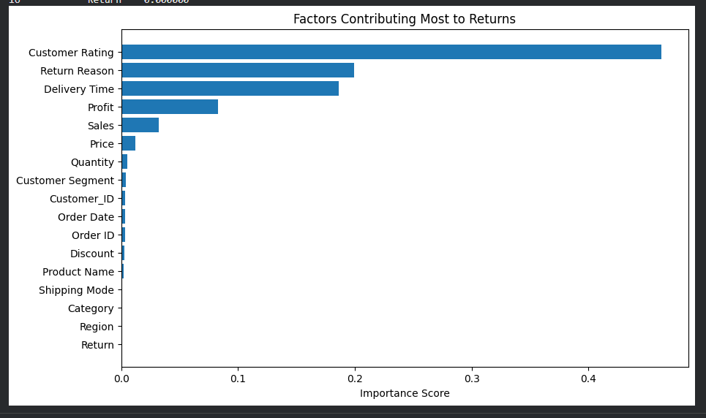
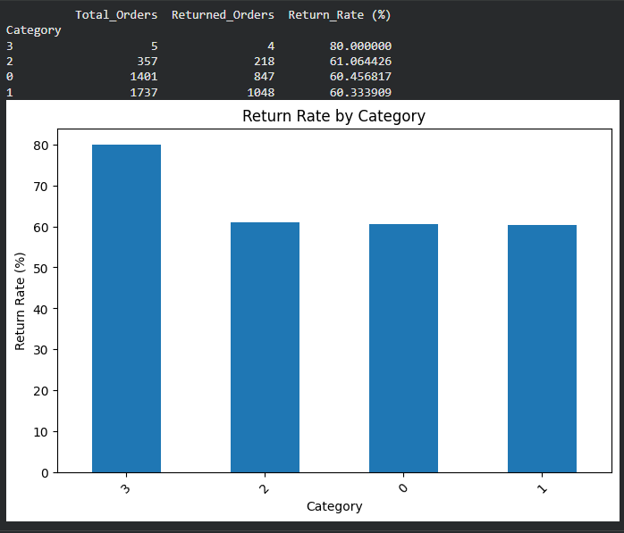

Innovation:
pandas
numpy
matplotlib.pyplot
train_test_split
LabelEncoder
RandomForestClassifier

